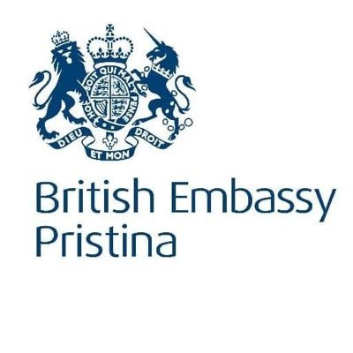 A close up of a logo

Description generated with very high confidence 

**Mentoring Programme for Judges and Prosecutors**

**RE-ADVERTISEMENT TO ALL CRIMINAL JUDGES**

**Further** to the earlier advertisement regarding the above programme the British Embassy together with the Kosovo Judicial Council announce the Re-advertisement of the Mentoring Programme in order to enable all judges dealing with the most serious Criminal Cases to apply to take part in the Programme. Judges who have already applied need not apply again as their applications will be considered.

The Programme will offer a unique positive learning experience with a view to improving skills and abilities for those dealing with the most serious forms of criminal cases that come before the Courts in Kosovo.

A key aim of the programme is to strengthen the professional skills, integrity and confidence of those selected to participate through tailored individual mentoring and training. Selection for the available places for the mentoring programme will take place by an open and merit-based selection process.

The programme will include intensive personal interaction with UK practitioners (Judges and Prosecutors) designed to enhance both technical and case management skills and helping to build career paths and prospects. Whilst most of the project activity will take place in Kosovo there will be study visits to England, currently planned for Spring and summer 2020, when the successful applicants will be able to meet Judges, Prosecutors and others working in the Criminal Justice Service of England and Wales, observe their ways of working, exchange ideas and gain valuable insights into best practice.

It is expected that having completed the programme participants will be able and willing to disseminate the benefits of their learning to their colleagues.

The programme will focus on management of cases of the greatest difficulty and seriousness such as high-level corruption, serious organised crime and money laundering.

**Successful participation in the programme will**:

* Support individual and career development;
* Help increase public confidence in the criminal justice system;
* Assist the participants in enhancing their skills and abilities in dealing with the most challenging criminal cases that come before the Courts.

**You must meet the following eligibility criteria and must:**

* Be a Judge with a permanent mandate currently assigned to the Special Department Prishtina (trials or appeals) or currently assigned to the Serious Crime Department of a Basic Court; or an Appeal Court judge dealing with appeals in serious criminal cases.
* Be willing to undergo any verification process which may be required by any of the UK Organisations involved in delivering the mentoring programme;
* Have a valid passport or be able to apply for one and be willing and able to travel to the UK possibly for an extended period of time;
* Obtain the consent of your Court President to participate in the project;

**You will be assessed against the following criteria and selected based on merit:**

* **Language requirement -** A reasonable level of fluency in the English language ability is desirable but not essential. Should an applicant be selected who does not have the ability to speak English then they will be provided with language assistance.
* **You must demonstrate:**
* A high level of professionalism and personal commitment towards your own personal development and the mentoring process.
* A willingness and ability to deliver training to others based on your own learning from the mentoring programme.
* The following professional competences:
* effective decision making;
* effective problem solving;
* impartiality;
* integrity;

You should explain how you meet these assessment criteria in the Application Form.

**Submitting your application:**

Judges who wish to apply for this opportunity should complete the attached Application Form and ensure that it is submitted by email to Mark Dixon [markdixon@agencialtd.com](mailto:markdixon@agencialtd.com) by no later than Friday 4th October 2019. Interviews are currently planned for w/c 21st October 2019.

Further information may be obtained from [markdixon@agencialtd.com](mailto:markdixon@agencialtd.com) Blerina Jashari [blerina.jashari@axiom-international-ltd.com](mailto:blerina.jashari@axiom-international-ltd.com) or [jovic.miodrag@gmail.com](mailto:jovic.miodrag@gmail.com) who will be delighted to assist.